Swinburne University of Technology

School of Science, Computing and Emerging Technologies

Contribution Document

Subject Code: SWE30003
Unit Title: Software Architectures and Design
Assignment number: 03
Assignment Title: Design Implementation
Due date: Aug 5th, 2026
Tutorial Day and Time: Mondays, 13:00 - 16:00 p.m
Project Group: SG3_3
Tutor: Mr.Pham Thai Ky Trung

- Time spent (hours): fill in the time spent on each significant work item in the following table.

Work Item | Truong Ngoc Gia Hieu | Lu Nhat Hoang | Duong Nguyen Dang
Project Scope, Domain Vocabulary and Analysis | 3 | 4 | 5
Architecture, CQRS and DB Design (ERD) | 6 | 2 | 3
Tasks and Support Specification (Parts D and Functional Requirements) | 5 | 6 | 6
CRUD Validation Matrix and Quality Attributes | 2 | 3 | 5
Workflows and Activity Diagrams (Part E) | 2 | 6 | 3
Final Integration, Formatting and QA | 5 | 2 | 2
Total | 23 | 23 | 24

Description of contributions:

- Truong Ngoc Gia Hieu: Led system architectural design (CQRS, Read Replicas, Pessimistic Locking) and created the Entity Relationship Diagram (ERD). Authored task specifications for Fleet Asset Management (Task 4.3) and Real-Time Transit Tracking (Task 4.6). Responsible for report integration, document formatting, and overall quality assurance.

- Lu Nhat Hoang: Mapped regional hub operations and financial settlement workflows. Authored task specifications for Branch & Hub Setup (Task 4.2), Process Order Modifications (Task 4.8), Automated Invoice Generation (Task 4.9), and Payment Reconciliation (Task 4.10). Designed operational Activity Diagrams and workflow models.

- Duong Nguyen Dang: Conducted domain vocabulary and enterprise pain point analysis. Authored task specifications for User & Access Management (Task 4.1), Order Management (Task 4.4), Shipment Scheduling & Dispatch (Task 4.5), and Handle Delivery Exceptions (Task 4.7). Co-developed the CRUD validation matrix and quality attribute scenarios.

- Evidence of collaboration / teamwork on each significant work item :

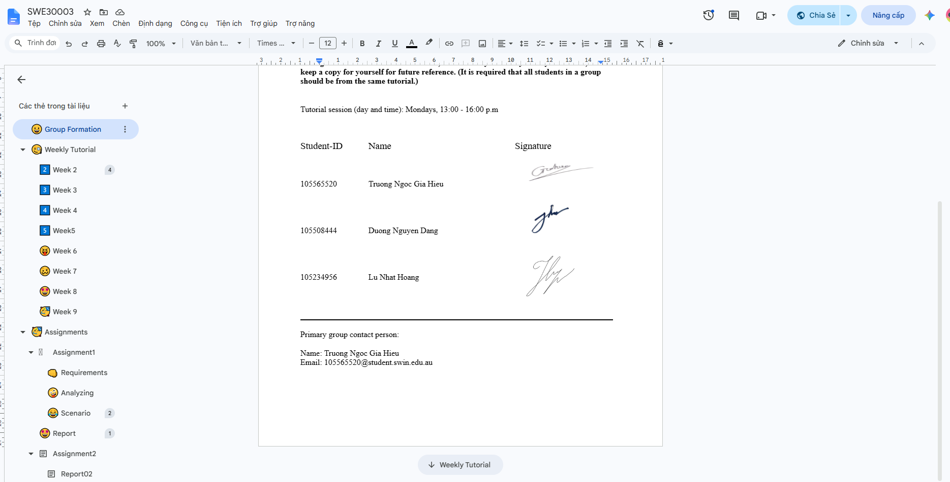
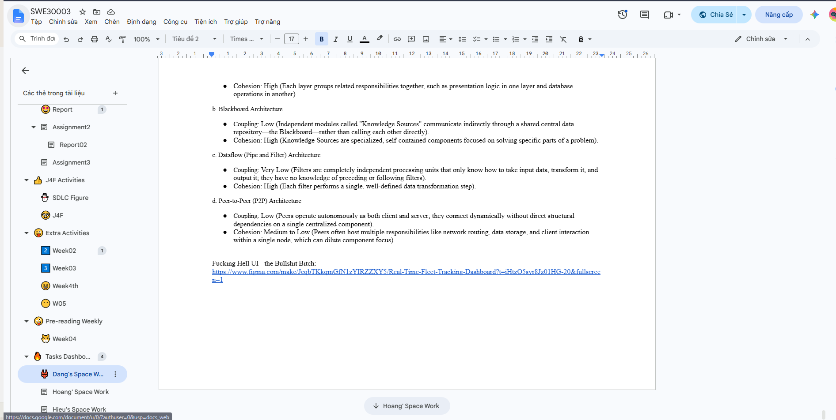

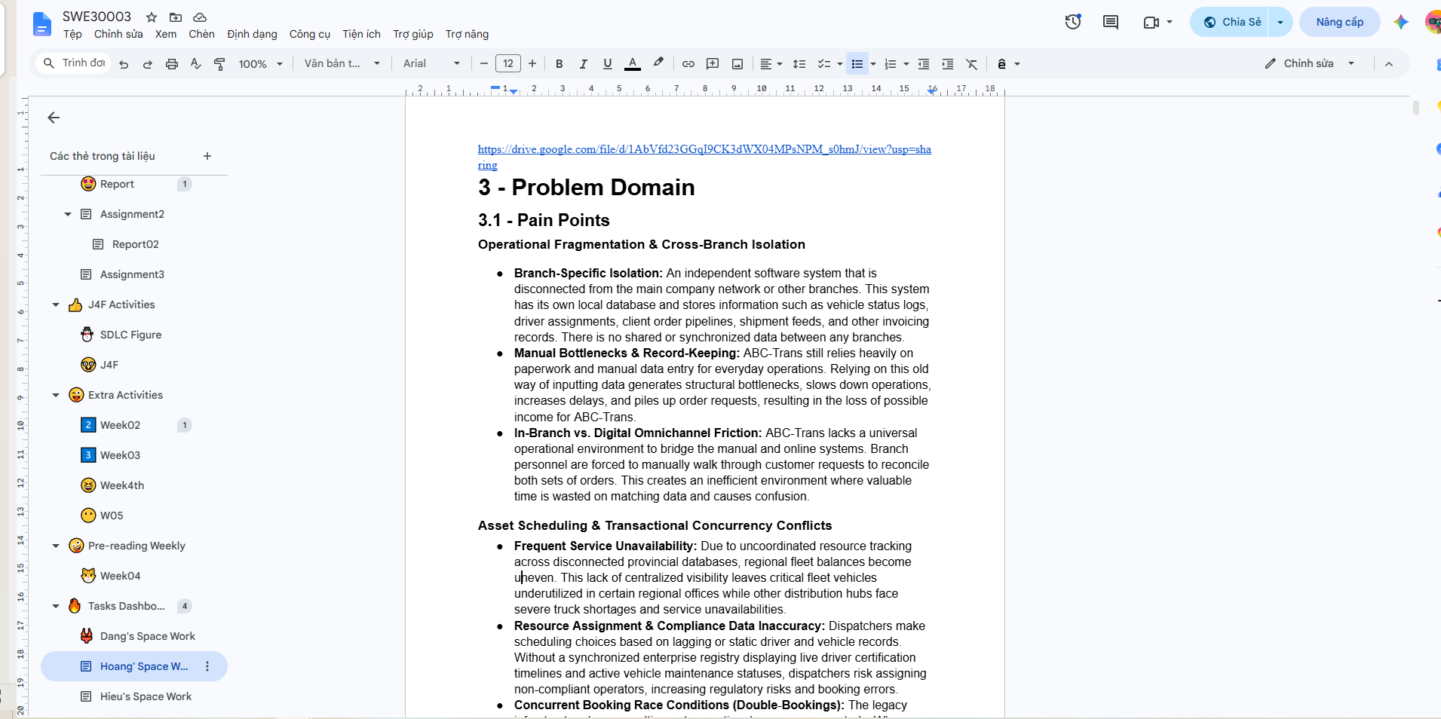

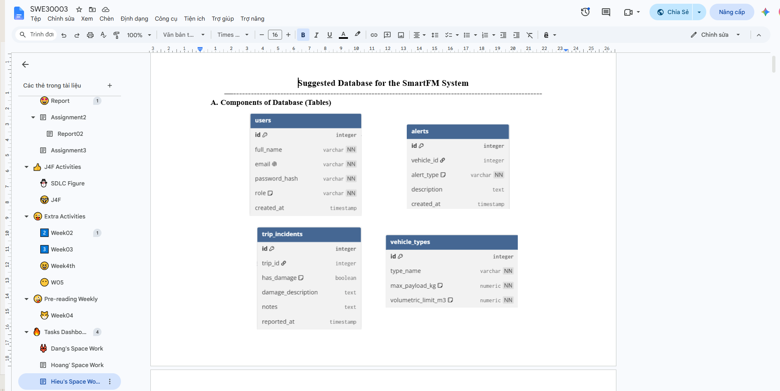

- Signed by all members:

Student-ID Name Signature
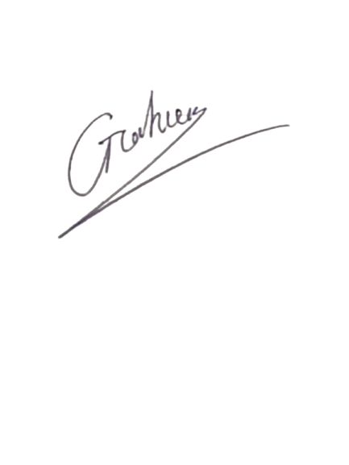
105565520 Truong Ngoc Gia Hieu
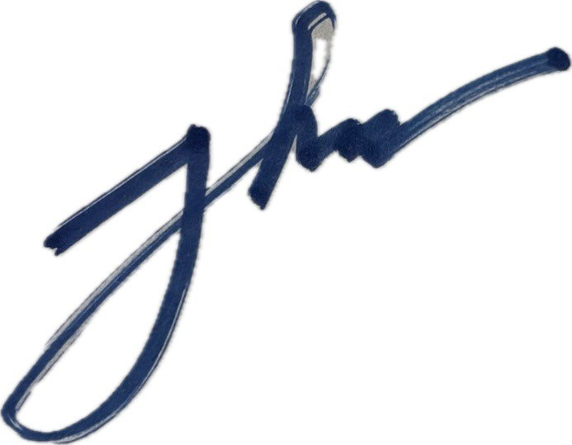
105508444 Duong Nguyen Dang

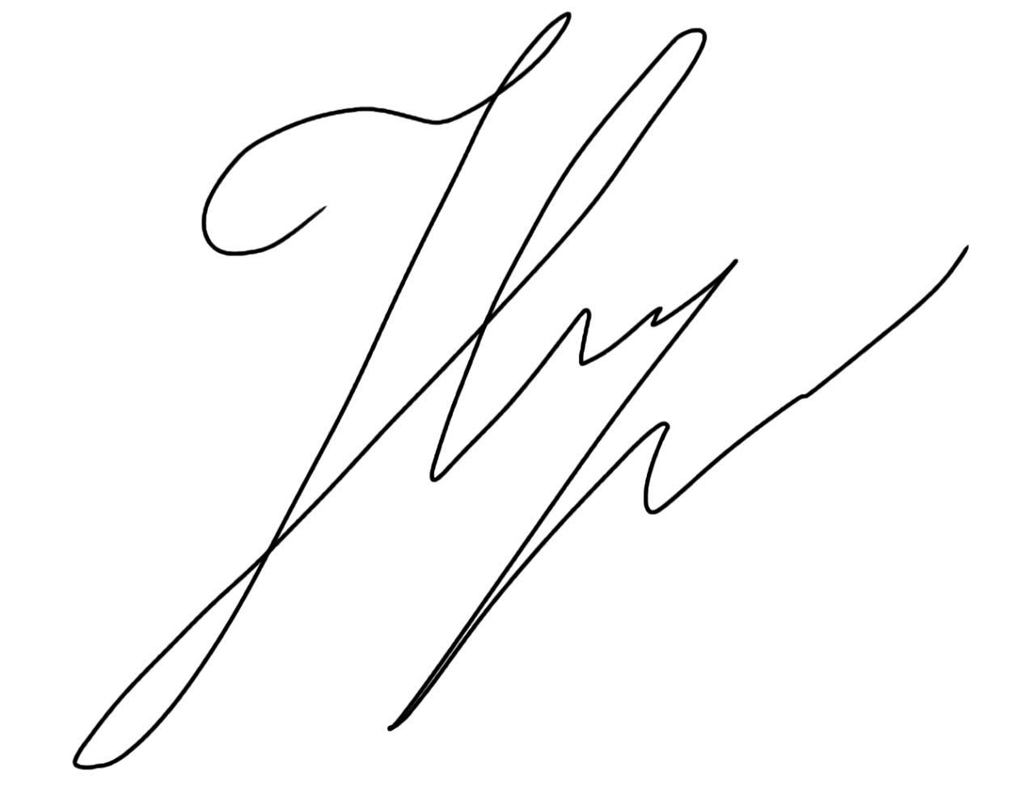

105234956 Lu Nhat Hoang

